 **1 May 2015** **The Weekly Bulletin of Rotary Club of Kathmandu Mid-Town** **bc-42/5.015**

|  |
| --- |
|  |

District: 3292 Web:www.rotarymidtown.org.np Club Id: 26776

**MAY IS THE ELEVENTH MONTH OF ROTARY YEAR 2014-15**

Club’s Weekly Meetings # 1276 on Friday 24 April:

Extracts of the Minutes # 1276:

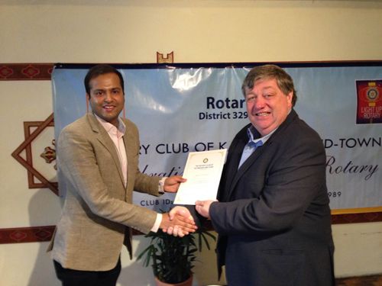

VP HE Peter Bodde providing a certificate of Appreciation to Guest Speaker Jalan

*Photo Courtesy*: *Rtn Shyam R Thapaliya*

“1. The meeting was called to order by 1st VP HE Peter Bodde.

“3. The VP welcomed the members and visiting Rotarian David

LaSueur (RC 1000 Islands, Brockville, ON, Canada) and

his wife.

“7. The speaker (and prospective member) Mr Prasun Jalan

was introduced by PP Ambica. He spoke on 'My views on

four recent talks at Mid-Town'. Mr Jalan said that he had

really enjoyed his recent visits at Mid-Town and today he

wanted to share his thoughts on some of the talk that he

had heard. He commented on a recent talk on the

presentation topic on AIDS and that it was deplorable how

poorly people with this disease were treated – here people

needed more education to better understand the disease.

On talks about political instability he commented that civil

society should just get on with conducting business – be

part of the solution. He gave the example that Nepal could

make available a freight corridor between China and India –

and that all three neighbors could benefit. Building

infrastructure is very important because it fertilizes society at all levels. He also touched on the role that the media can play – media needs to be the watchdog that keeps both politicians and civil society accountable to all. He summarized his views by saying that the two most important things were education and economic prosperity. Rtn HE Asko gave the vote of thanks.

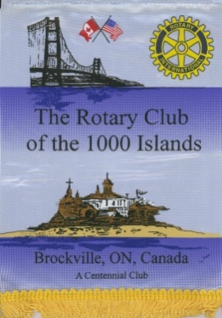”8. Information sharing:

> The committee chairs were reminded to please submit their year end reports.

> Treasurer Yo reported on the financial accounting for the charter night and the raffle- night, overall there is a small net surplus.

> Exchange of flags with Rtn David LaSueur (RC 1,000 Islands, Brockville, Ont. Canada).

> PP Mani reminded about upcoming district-level meetings for incoming officials. PE Paras said that the matter was well in hand.

> VPs Peter and Lisa informed about a newly released book on the recent history of Nepal, 'The Nepal Scene, The Chronicles of Elizabeth Hawley'. This is a two-volume set.

> Treasurer Yo reminded that the Spring concert by The Kathmandu Chorale is going to be a special one, with the live performance of Carl Orff's Carmina Burana! Save the Date: Saturday May 9.

“9. Statistics of the meeting: Members present: 22”

# Weekly Meetings and Programs :

|  |  |  |
| --- | --- | --- |
| Date | Program/ Speaker | Topic of Presentation |
| 1 May | No guest speaker | Emergency meeting at Annapurna Hotel garden area |
|  |  |  |

Weekly Meeting on Friday, 1 May:

The great earthquake of 7.6 magnitude hit Kathmandu Valley and 10 other districts of the country on 25 April and several after-shocks with magnitudes ranging up to 6.9 Richter Scale.

Emergency meeting to discuss how best to respond both to the appeals for help and to the very generous offers of assistance that are coming in from Clubs around the world.

**District Training Assembly**

District Training Assembly is going to be held on 9 May 2015 in Little Angle's School, Hattiban, Lalitpur.  This is a very important District event and Incoming Club Officials: President-elect Club Secretary, Treasurer, Chair Persons of Five Standing Committees: Club Administration, Membership, Public Relation, Service Project and The Rotary Foundation are encouraged to attend the training assembly.

Travel / Tourism

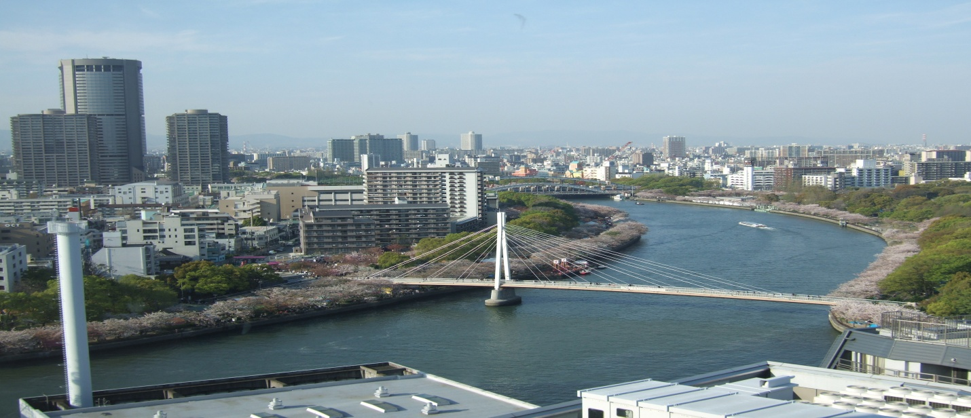

“The World is a book, and those who do not travel read only a page.”

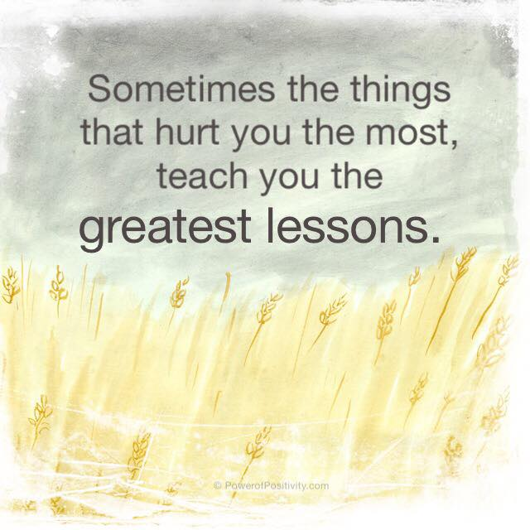



**A THOUGHT FOR TODAY:**

**[A person without a sense of humor is like a wagon without springs –](http://www.brainyquote.com/quotes/quotes/b/baruchspin101666.html" \o "view quote)**

**[jolted by every pebble in the road.](http://www.brainyquote.com/quotes/quotes/b/baruchspin101666.html" \o "view quote)**

[- Henry Ward Beecher, preacher and writer (1813-1887)](http://www.brainyquote.com/quotes/quotes/b/baruchspin101666.html" \o "view quote)

*[Courtesy: Rtn IsabellaC Bassignana Khadka](http://www.brainyquote.com/quotes/quotes/b/baruchspin101666.html" \o "view quote)*

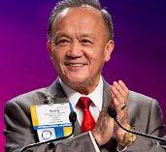

\ We need to assume leadership for building strong clubs, and that starts with bringing in

new members.

**RI President GARY C.K. HUANG**

## 1 May 2015 The Weekly Bulletin of Rotary Club of Kathmandu Mid-Town bc-42/5.015

******************************************